**Part 1: Investigate the MEGACORP2020 Data**

*1.How many columns and row are in the MEGACORP2020 table?*

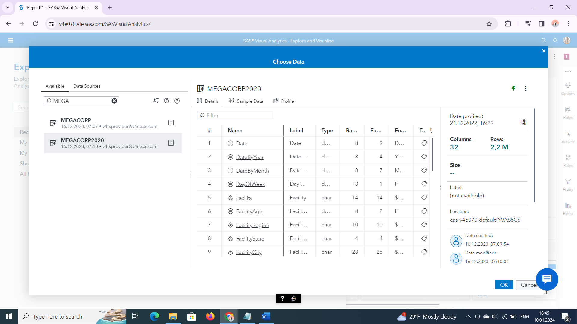

*2.What are the different data classifications in the Data pane?*

Category, Measures, Aggregated measures

*3.How many date data items are in the table and what are their formats?*

TREI- Date(Date9), Date by month(MONYY7), Date by year(YEAR4)

*4.Are there any measures that are not suitable for arithmetic analysis? Are they appropriate to use as a category data item?*

Da. Day of Week si Product ID

*5.What is the default aggregation for Unit Reliability and Unit Yield (rate)? Are the aggregations appropriate for these data items?*

Agregarea implicita este suma (Sum). Unit Reliability si Unit Yield (rate) sunt procente deci o agregare nonaditiva ar fi potrivita.

**Part 2: Prepare the MEGACORP2020 Data**

1. *Based on your findings in Part 1, change classification types, modify formats and aggregations, and rename data items to meet your analysis and reporting requirements*

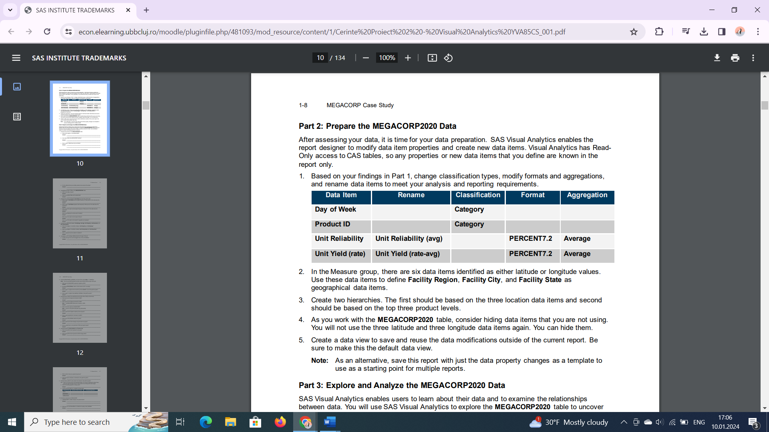

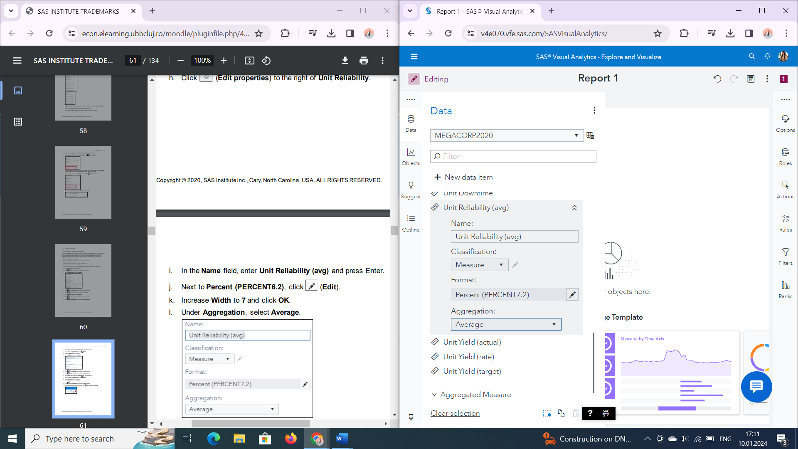

1. *In the Measure group, there are six data items identified as either latitude or longitude values. Use these data items to define Facility Region, Facility City, and Facility State as geographical data items.*

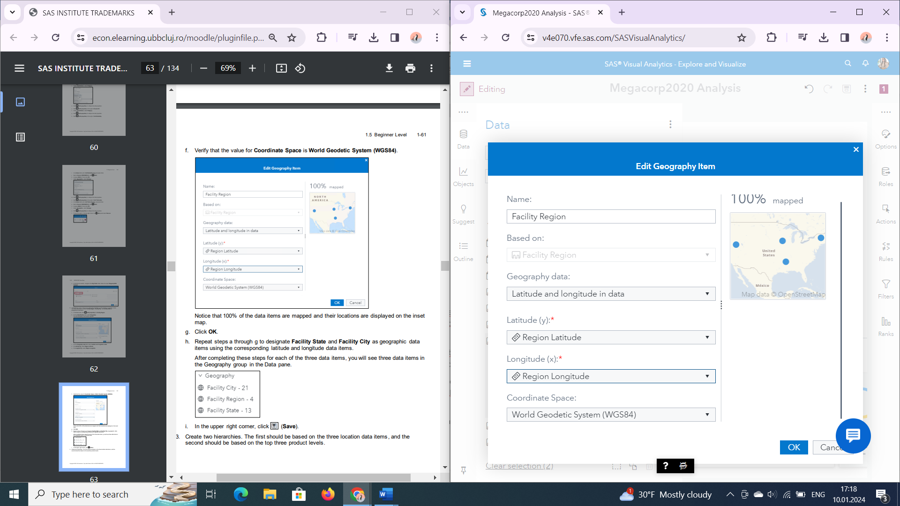

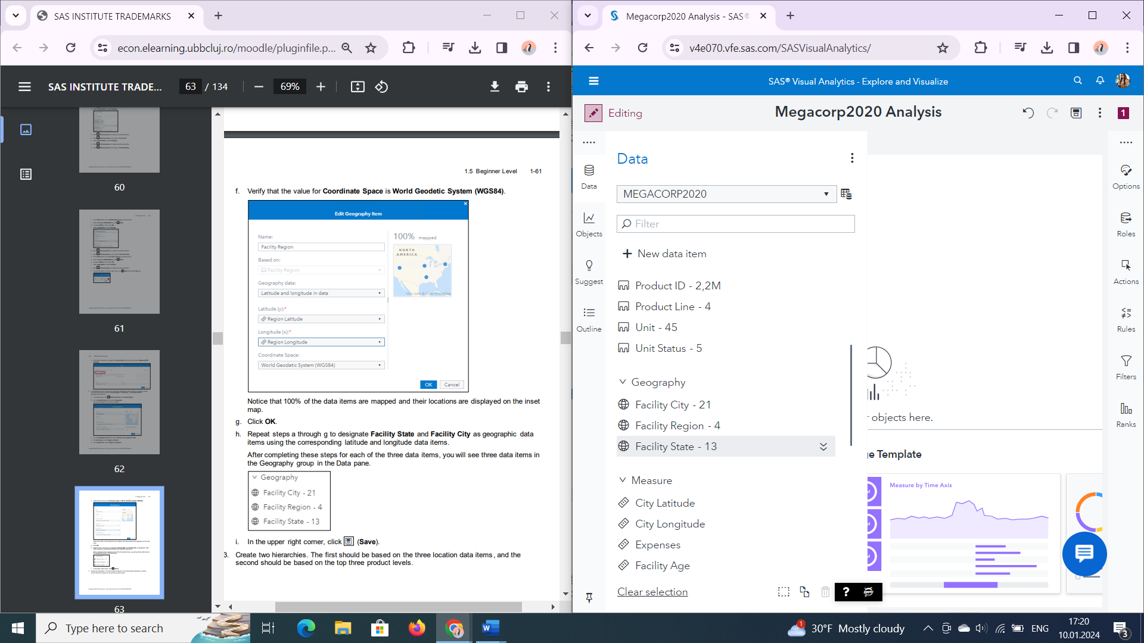

1. Create two hierarchies. The first should be based on the three location data items and second should be based on the top three product levels.

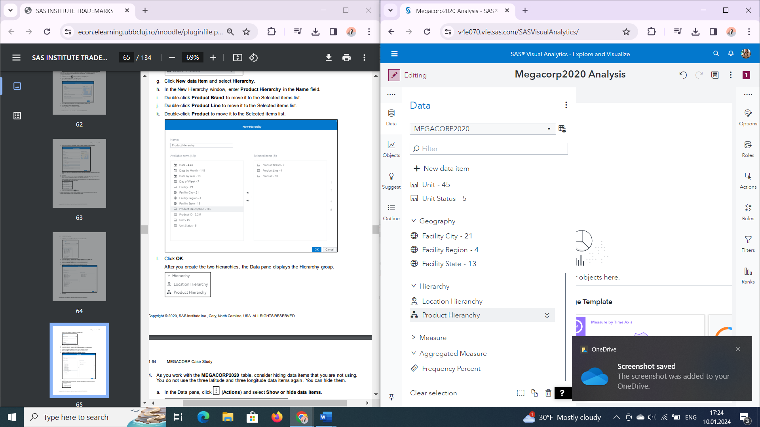

1. *As you work with the MEGACORP2020 table, consider hiding data items that you are not using. You will not use the three latitude and three longitude data items again. You can hide them.*

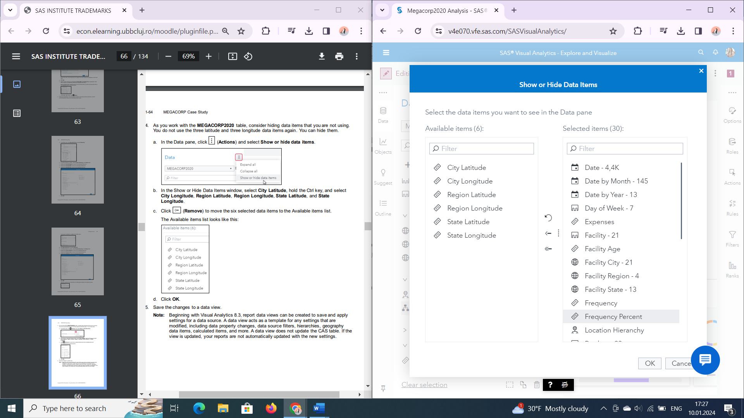

1. *Create a data view to save and reuse the data modifications outside of the current report. Be sure to make this the default data view.*

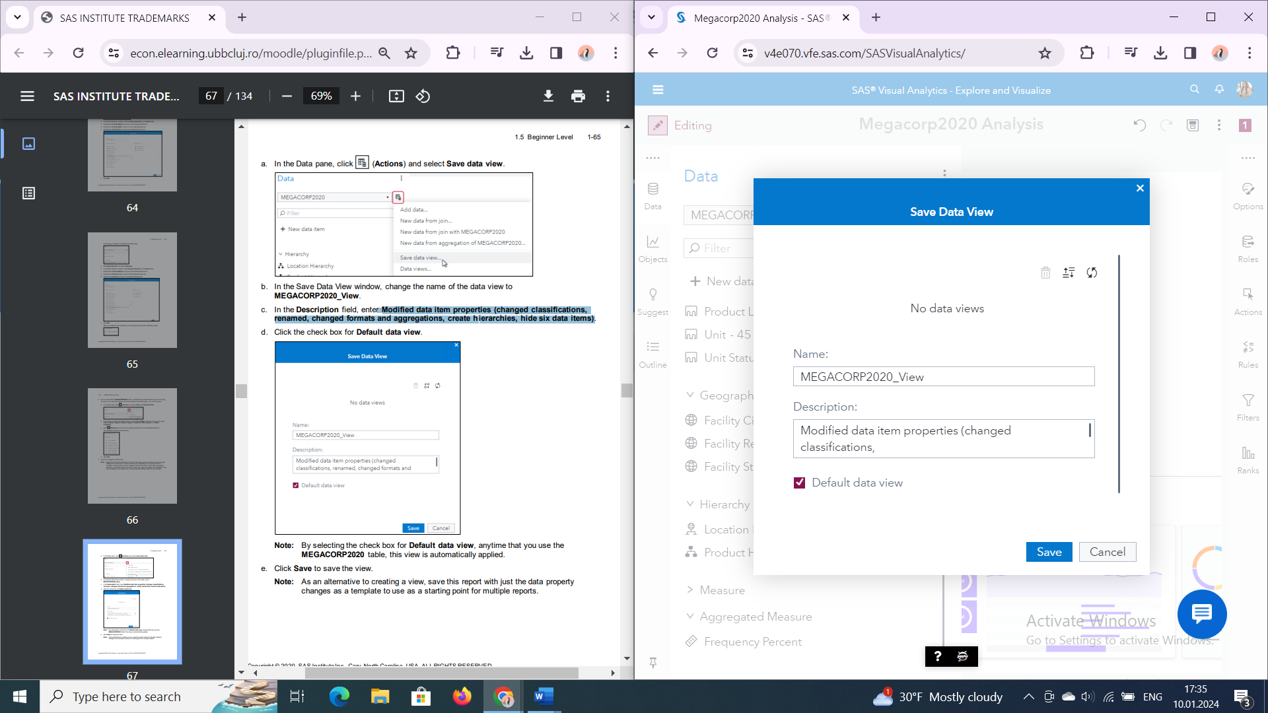

**Part 3: Explore and Analyze the MEGACORP2020 Data SAS Visual Analytics**

1. *Examine the structure of the MEGACORP2020 table*.

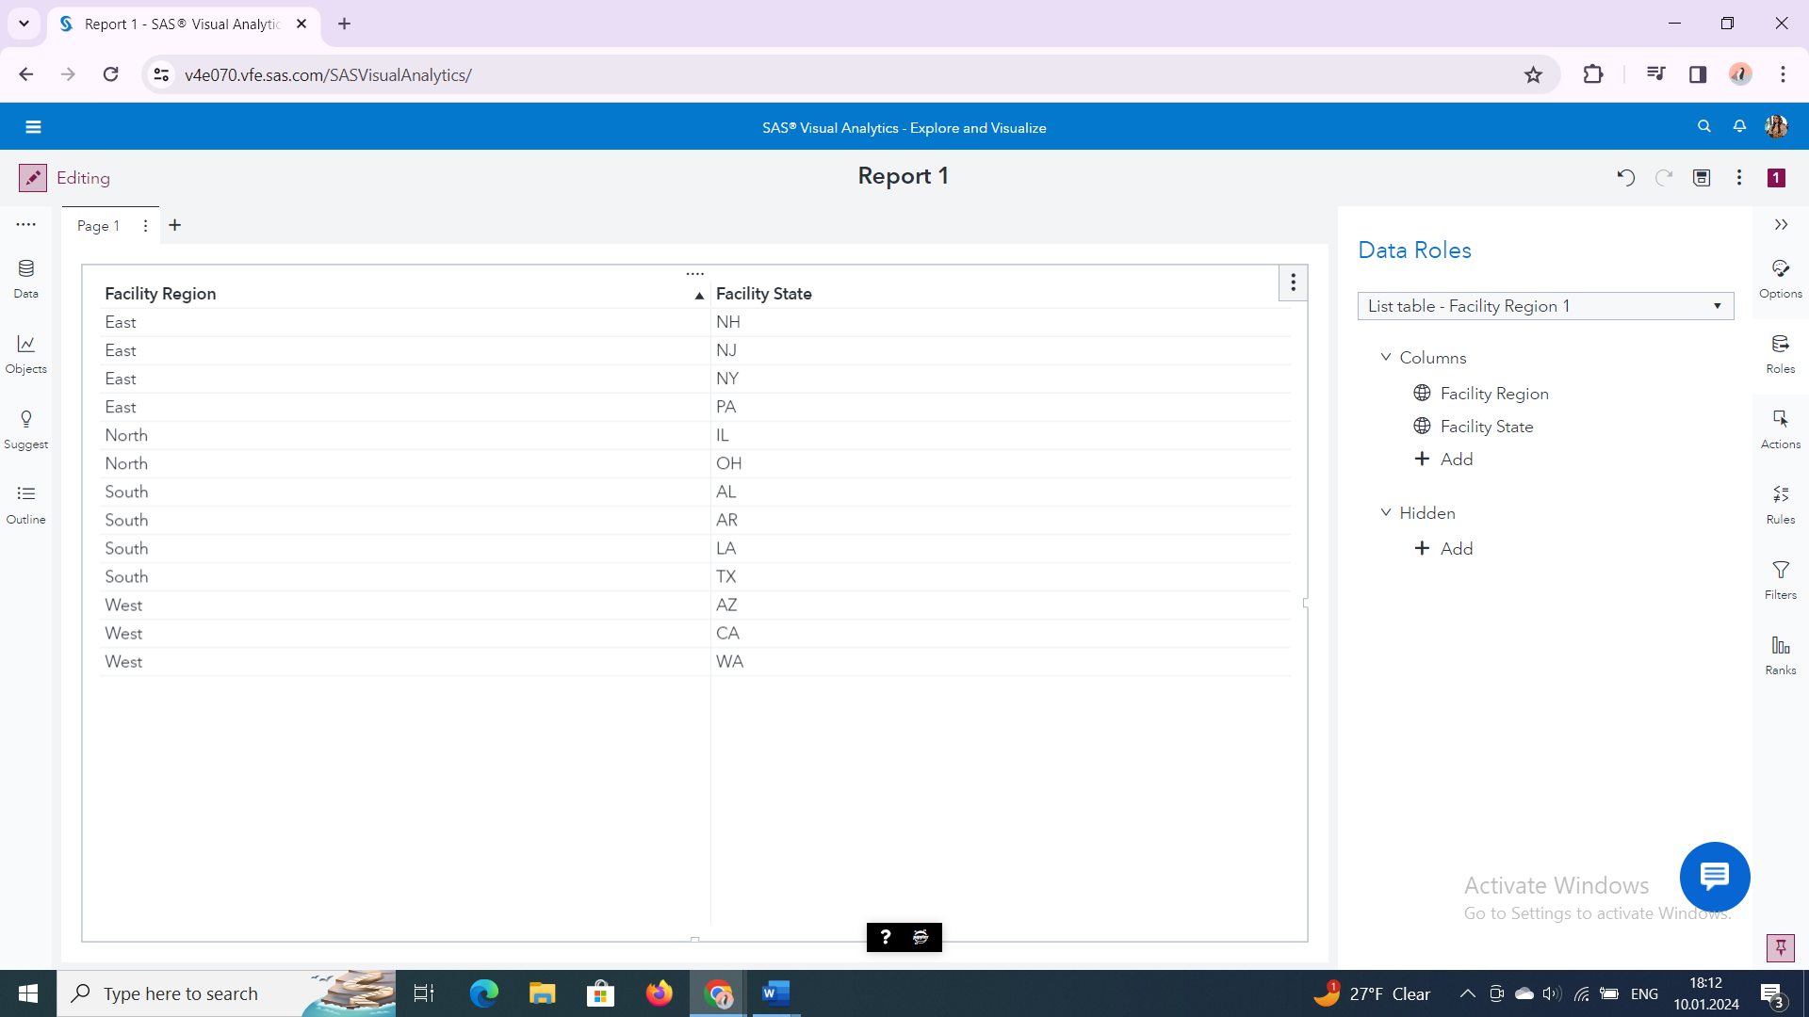

1. *What are the regions in the MEGACORP?*

Nord, Est, Sud si Vest

1. *How many states have MEGACORP facilities? -*13
2. *Which state or states have only one facility?*

AR,AZ,LA,NH,NJ,NY,PA,WA

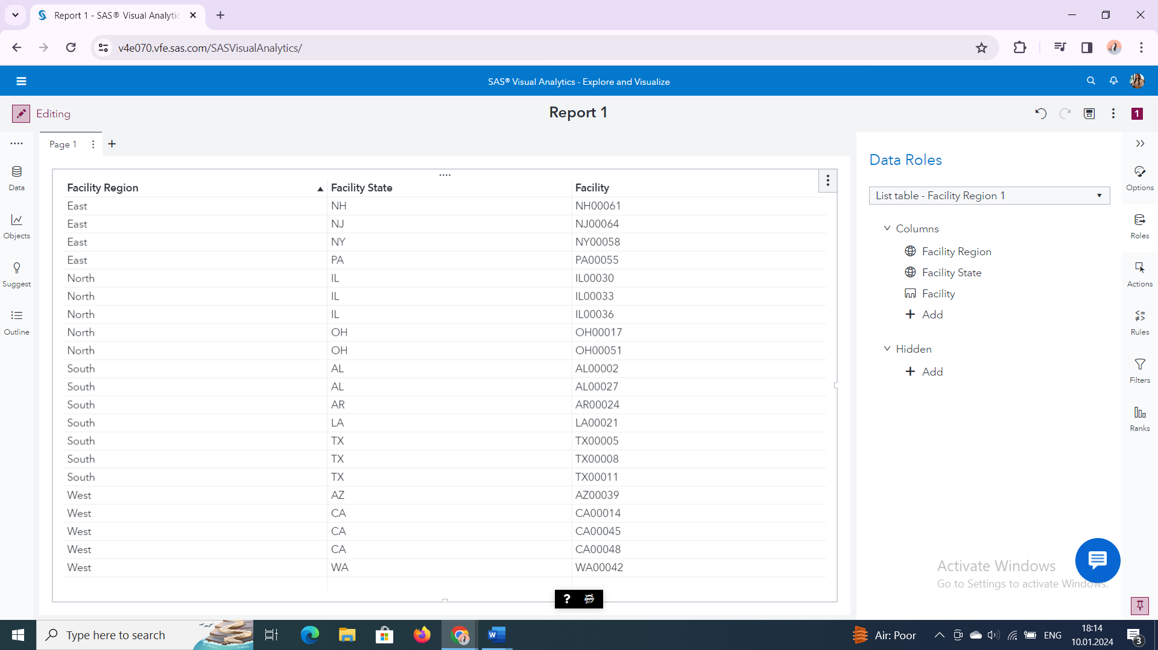

1. *For the states with only one facility, what are the names of the cities?*

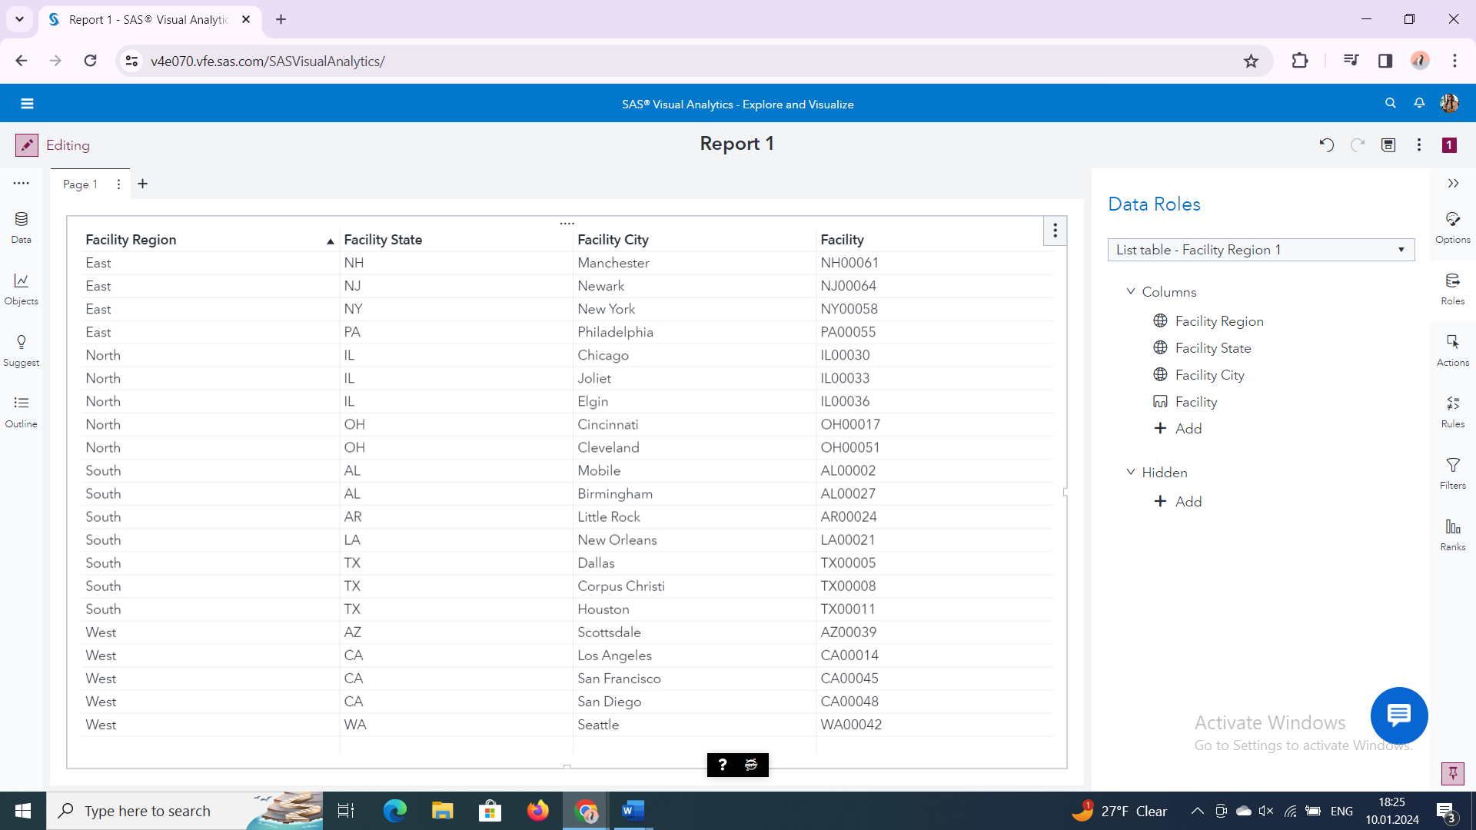

Little Rock, Scottsdale, New Orleans, Manchester, Newark, Philadelphia, Seattle

1. *Investigate the range of dates in the MEGACORP2020 table.*

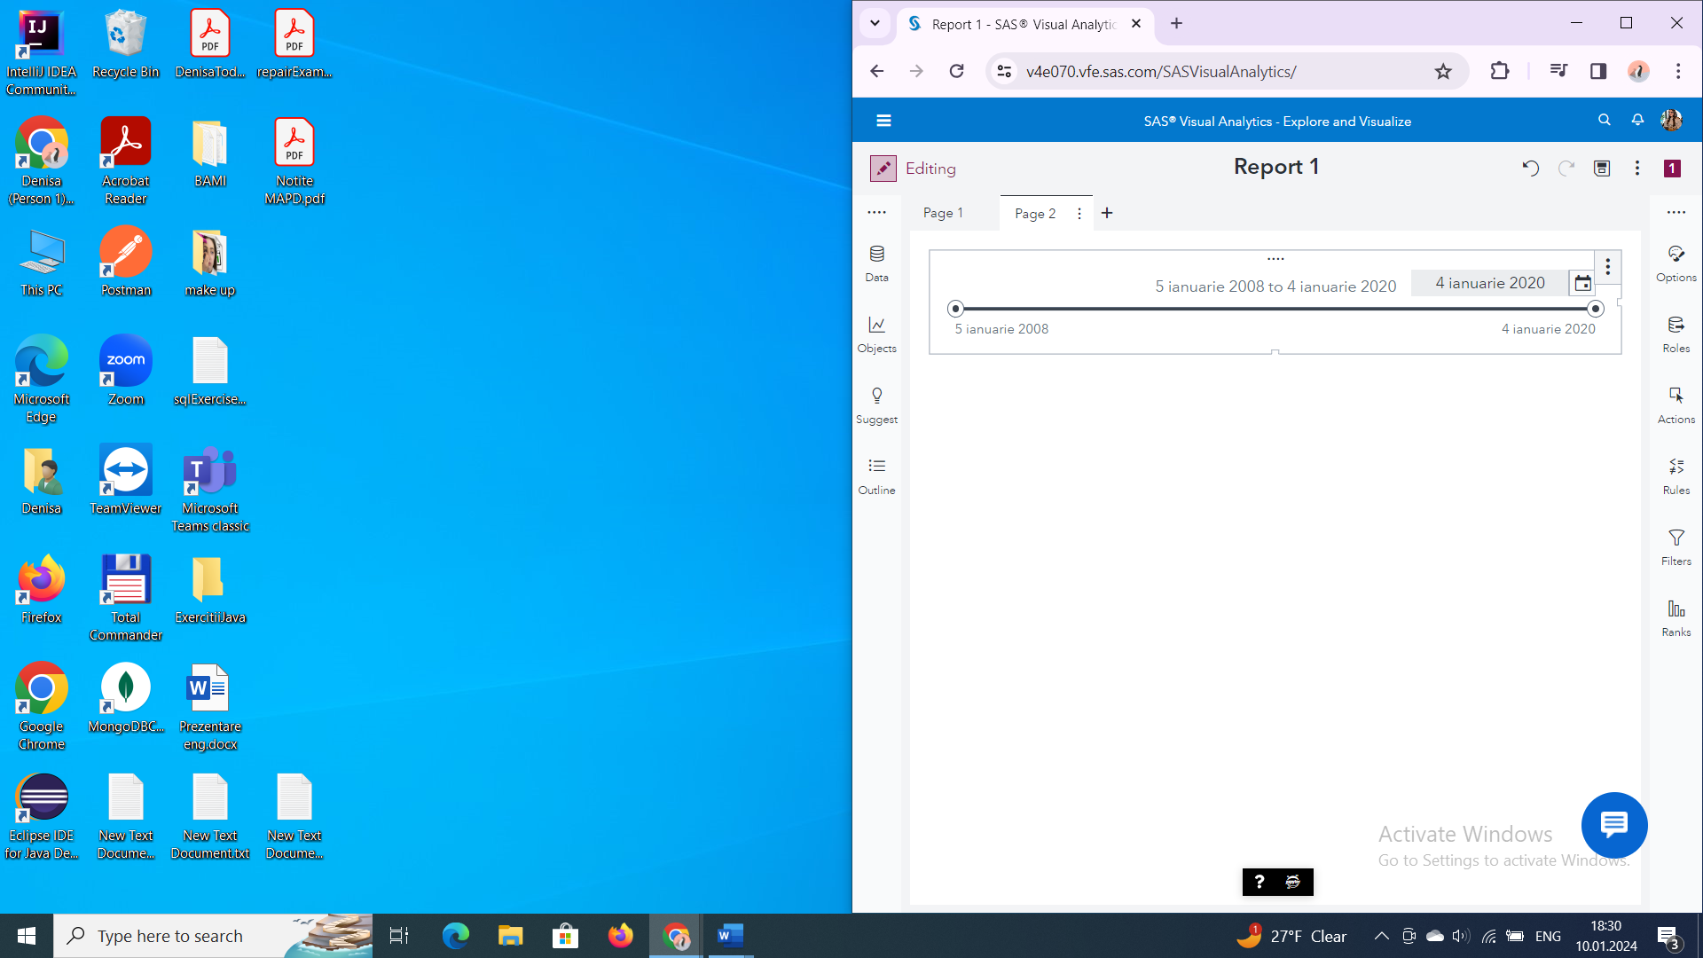

1. *What is the range of years?*

2008-2020

1. *What is the earliest date and the latest date?*

5 ianuarie 2008 – 4 ianuarie 2020

1. *Examine the counts and totals for Unit Status and each day of the week.*

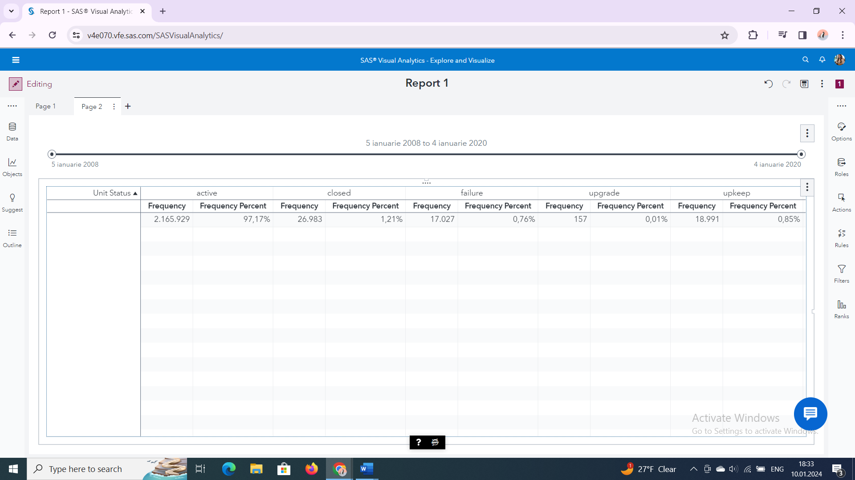

1. *Which value of Unit Status has the highest frequency? What percent of the data does this represent?*

Active, 97,17%

1. *Which value of Unit Status appears least frequently? What percent of the data does this represent?*

upgrade-0,01%

1. *Which day of the week has the highest frequency? What percent of the data does this represent?*

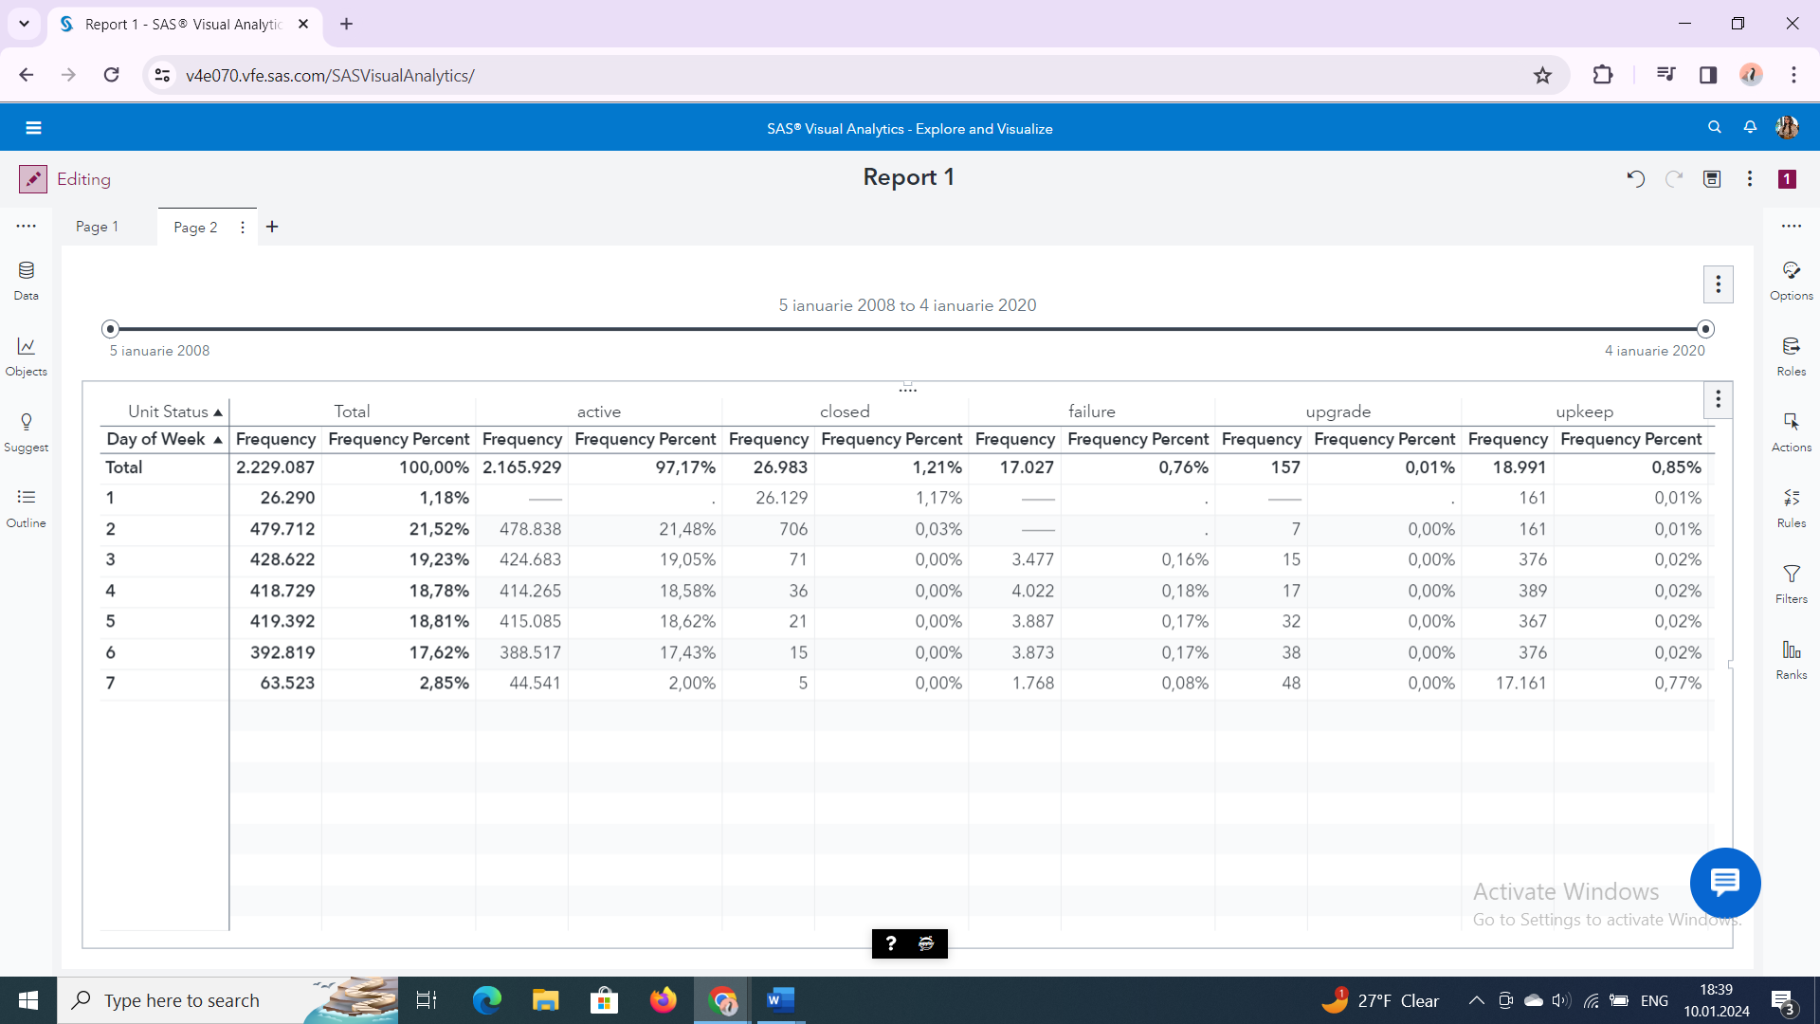

Monday-21,52%

*d.What is the frequency for active unit on Sunday?*

The frequency is missing, which means that active units are close on Sundays

*e.Which day of the week has the highest failures? -*Miercuri

*f.Which day of the week is the busiest for upgrades and upkeeps? -*Sambata

1. Examine the relationship between Facility Age, Unit Age, Unit Capacity, Unit Downtime, and Unit Yield (actual).

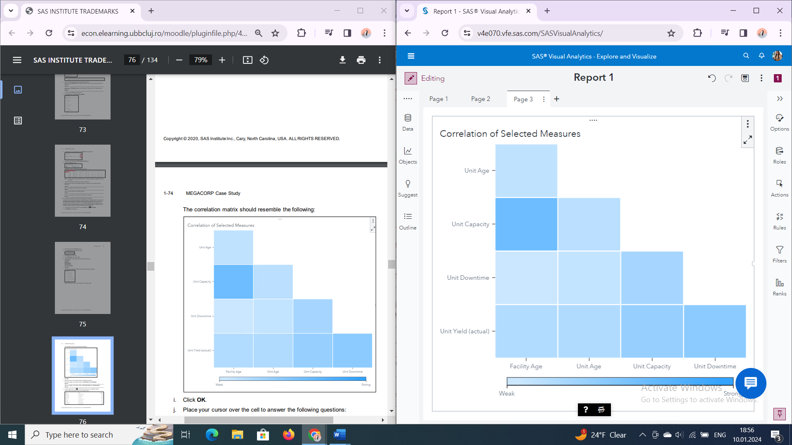

*a. What is the degree of correlation between Unit Capacity and Facility Age?*-1.6194

*b. What is the degree of correlation between Unit Yield (actual) and Unit Downtime?*

-4.132

*d.Which measures have the weakest correlation?*

Unit Downtime si Facility Age. -0.0057

1. Investigate a unit’s average reliability based on the age of the unit.

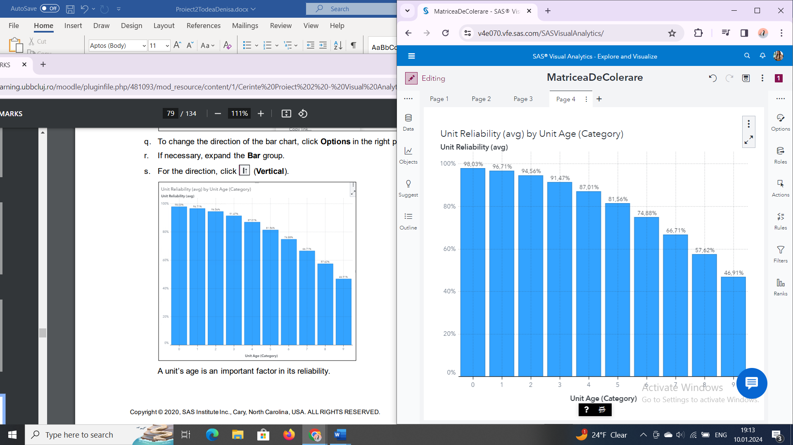

*a. At what unit age do we see the biggest drop in the unit reliability?* -9

1. *Examine MEGACORP’s profitability over the last five years (Date >= 1JAN2015).*

*a. What year did MEGACORP experience negative profits? -2017*

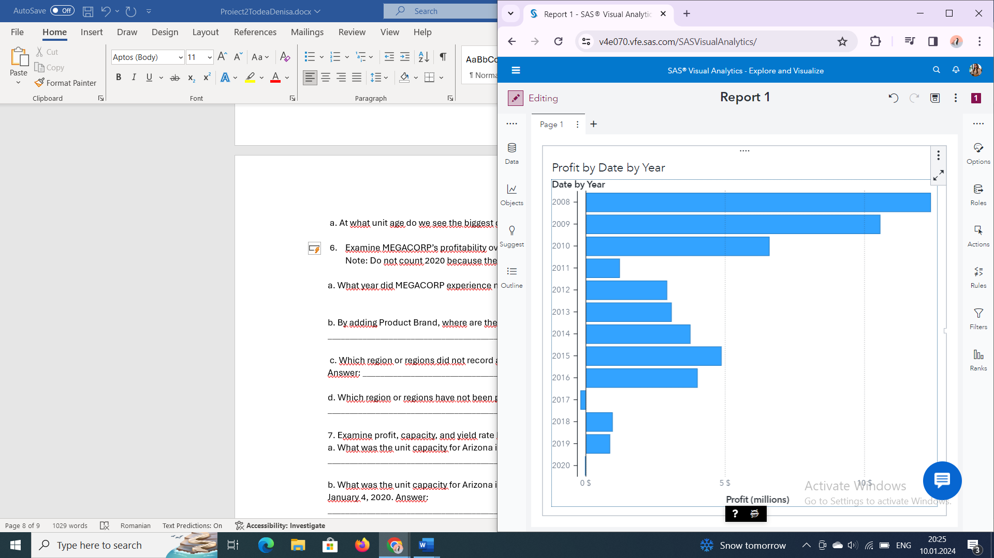

*b.By adding Product Brand, where are the losses in 2017 occurring? -Jucarii*

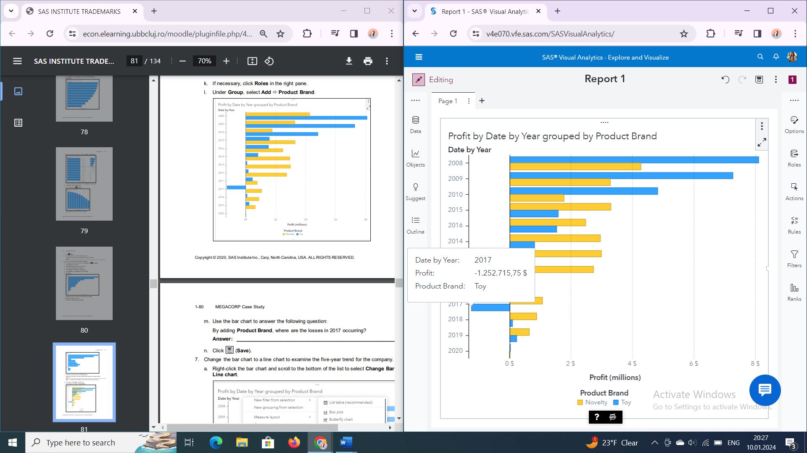

1. *Which region or regions did not record any losses (Profit < 0) over the past five years? -Vest*

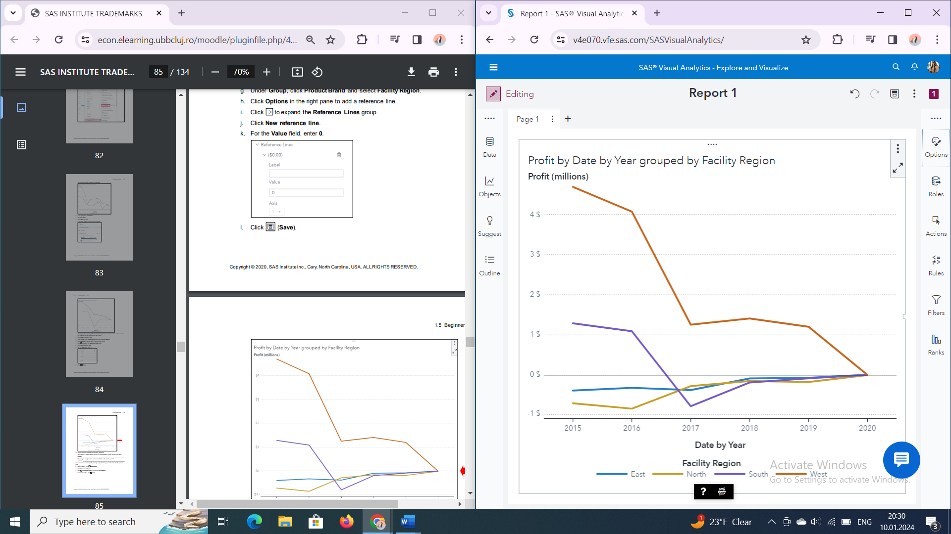

*d. Which region or regions have not been profitable in the past five years? -Est,Nord*

*7.Examine profit, capacity, and yield rate by year at the state, facility, and unit level.*

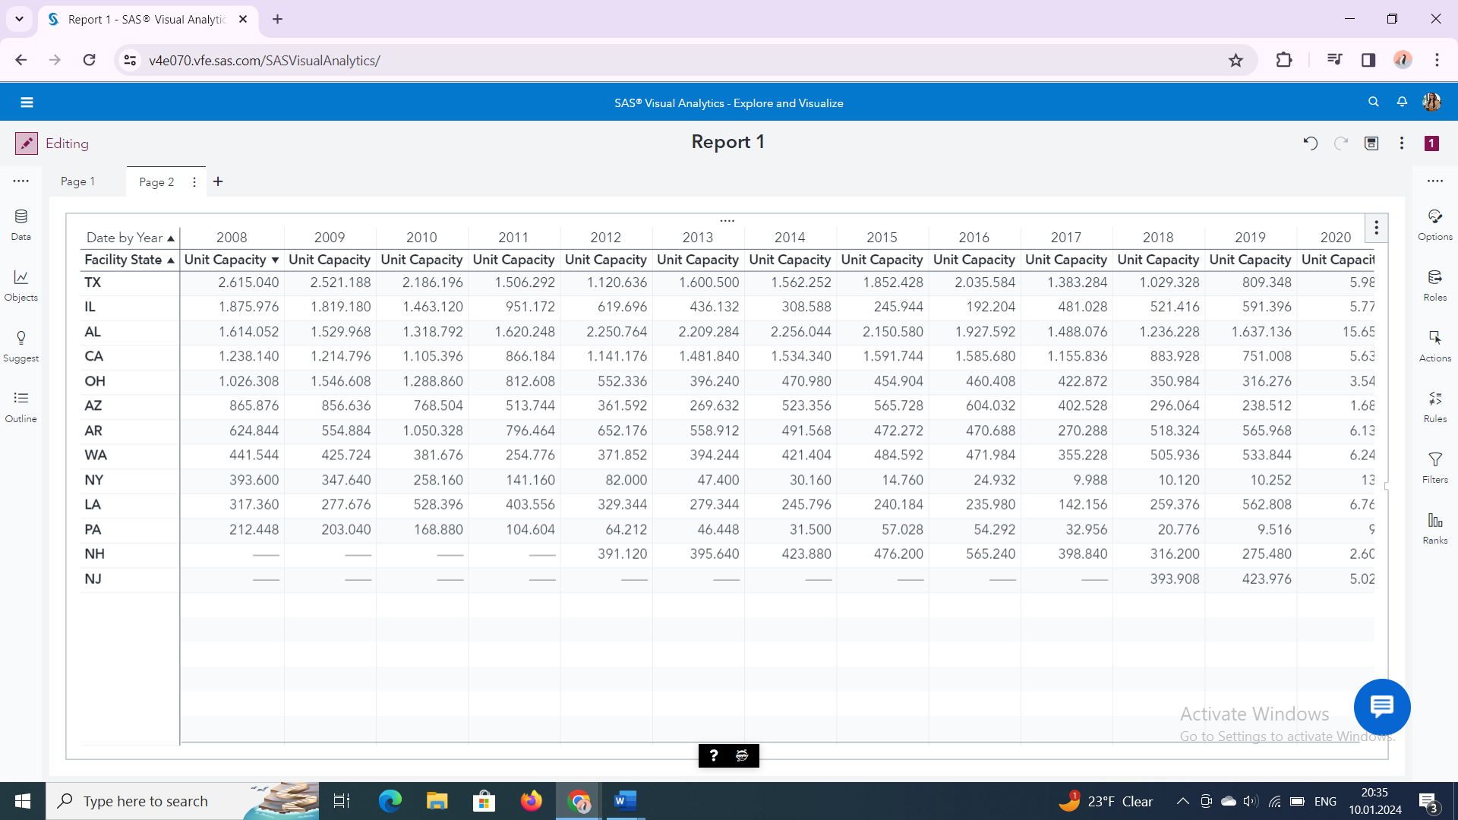

*a. What was the unit capacity for Arizona in 2008*? - 865.876

*b. What was the unit capacity for Arizona in 2020? Note: The MEGACORP data ends at January 4, 2020*.- 1,680

*c. What is the total capacity for MEGACORP? Note: Focus on the past five full years only (2015-2019)*- 36.846.168

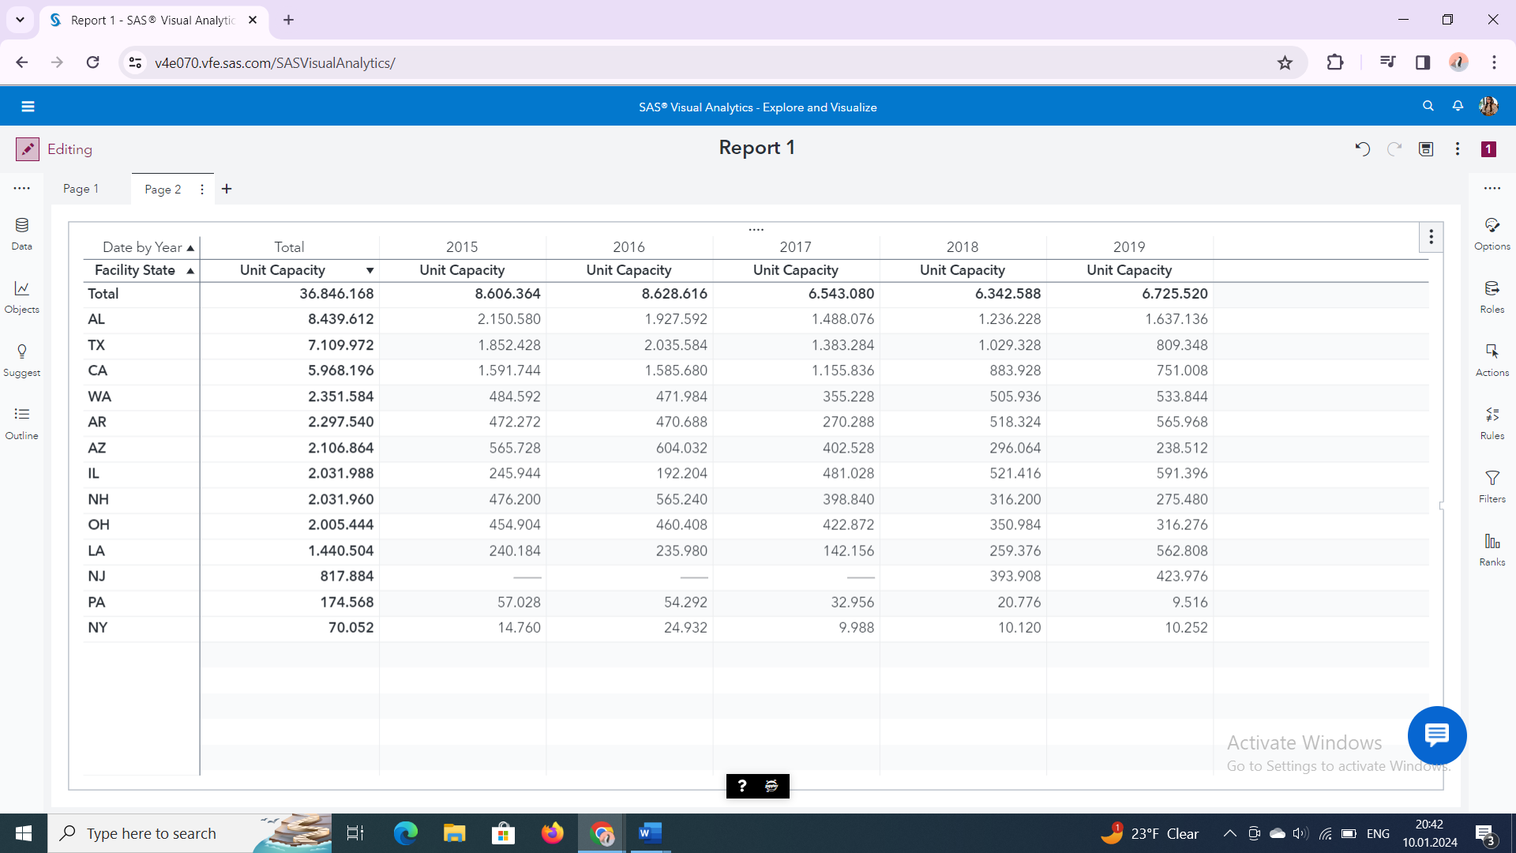

1. *Which state had the highest capacity across all years?*

AL- Alabama

1. *Which states experienced a decrease in profits?*

NY: New York OH: Ohio PA: Pennsylvania NH: New Hampshire LA: Louisiana AL: Alabama IL: Illinois

1. *What is the most profitable state for all years?*

California

*g. Which state has the best average unit yield rate for all years?* - New York

*h. Did any states have a unit yield rate of 100% and report losses? -NY in 2016 si 2017*

1. *Examine profits by Product Brand and Product Line*

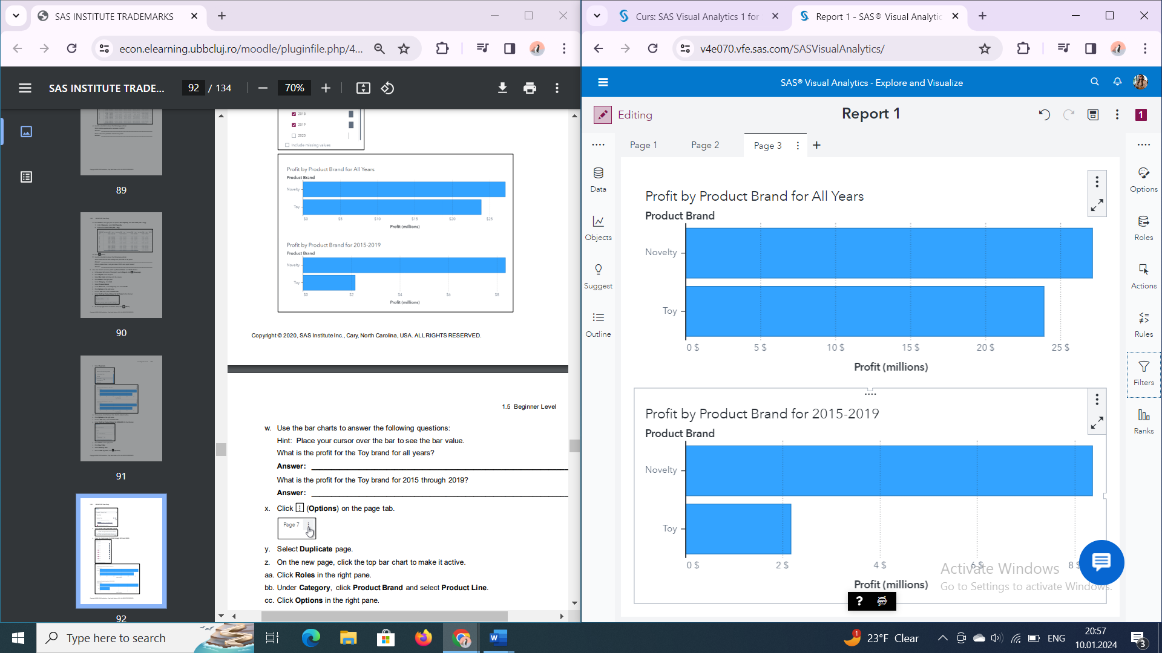

a. *What is the profit for the Toy brand for all years? - 23,871,222 dolari*

*b. What is the profit for the Toy brand for 2015 through 2019? 2,162,115 dolari*

*c. Which product lines are experiencing losses? -Animal de plus si Figurina de actiune*

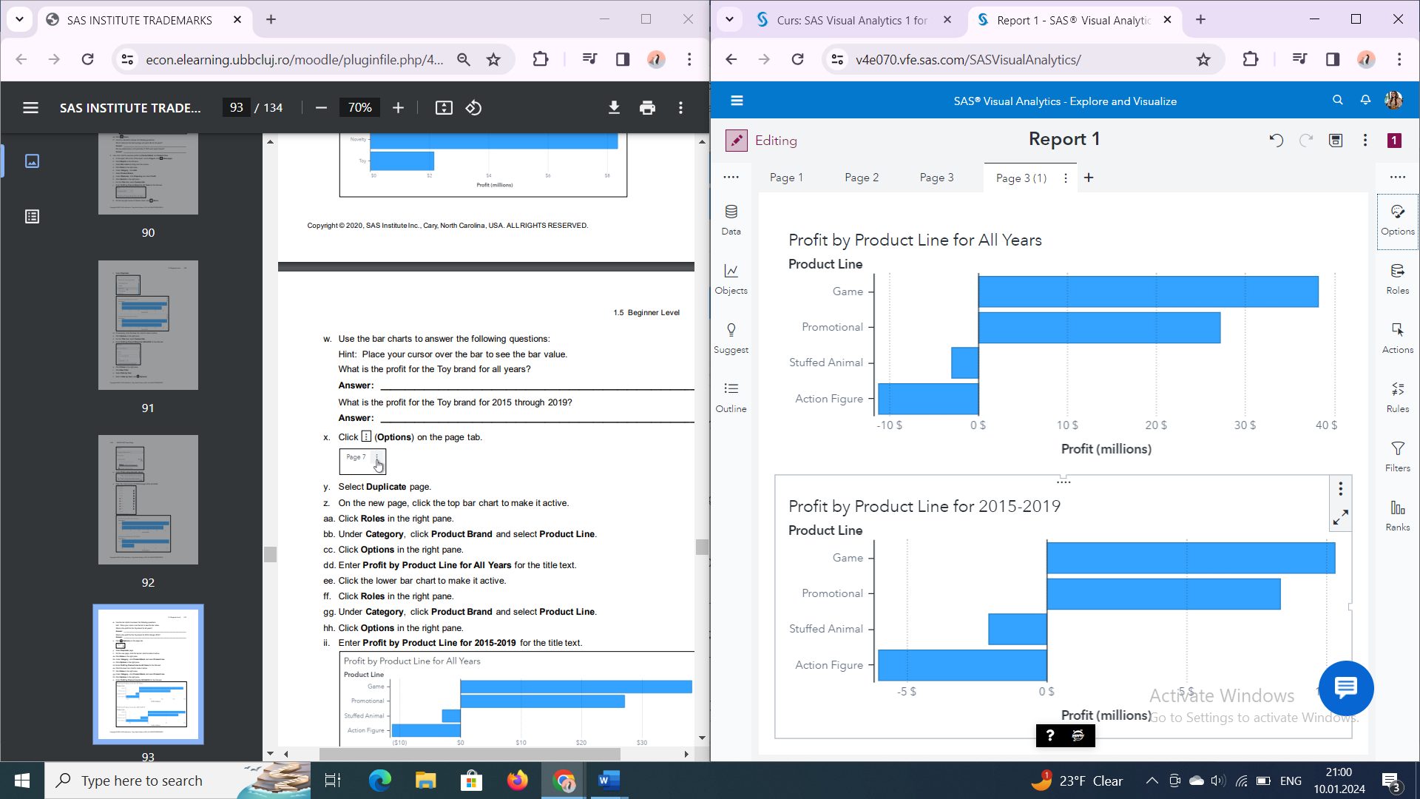

1. *Have the losses increased or decreased in the past five years? -Au scazut*
2. *Examine future profits for each product line based on the past five years?*

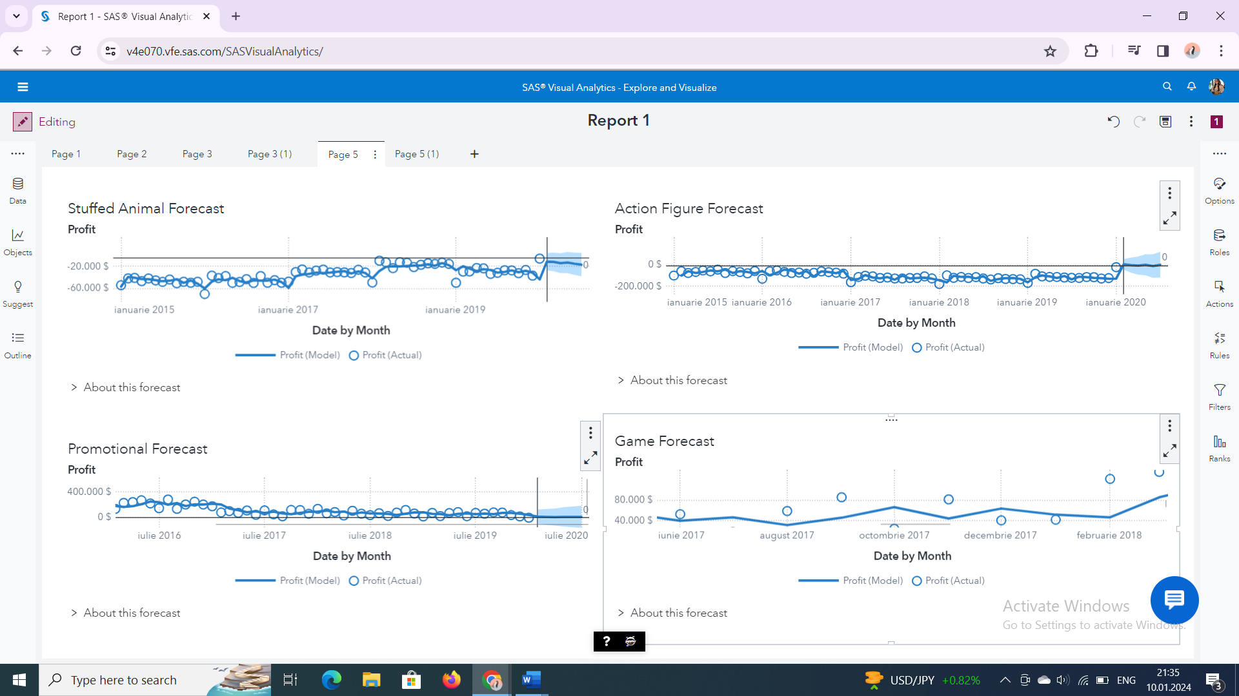

1. *Which forecasting algorithm is being used? ARIMA*

*b. Use the forecast objects to complete the table below.*

|  |  |  |
| --- | --- | --- |
| Product Line | Forecast: Gain or Loss | Forecast Algorithm |
| Game | Gain | ARIMA |
| Promotional | Gain | ARIMA |
| Stuffed Animals | Loss | Seasonal Exponential Smoothing |

*10. Provide an assessment of MEGACORP*

*a. Este MEGACORP o companie viabilă în forma sa actuală?*

Perspectivele de profit pentru următoarele șase luni indică o creștere modestă, semnalând că, în lumina tendințelor curente, MEGACORP s-ar putea să nu fie considerată o companie solidă.

*b.What are your recommendations to make the company more profitable?*

Pentru a crește profitabilitatea companiei, sugerez implementarea unor strategii precum optimizarea costurilor, diversificarea pe piață, inovarea produselor/serviciilor și integrarea tehnologiei.

**Part 4: Create a Report on the MEGACORP2020 Data**

